*Margie’s Travel Presents…* **New York**

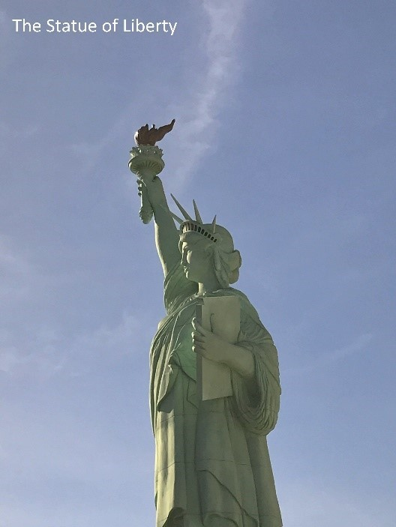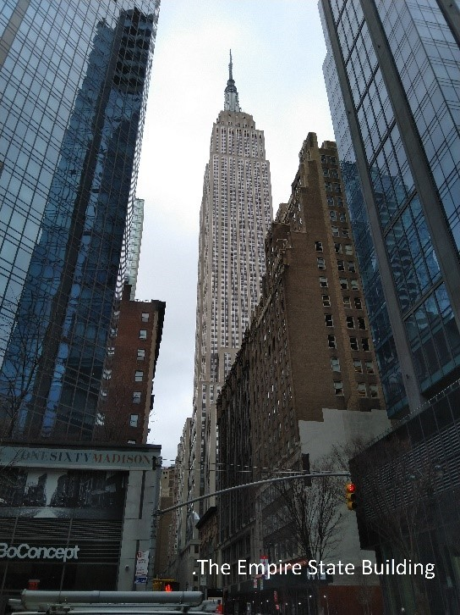The City of New York, often called New York City or simply New York, is the most populous city in the United States. With an estimated 2015 population of 8,550,405 distributed over a land area of about 302.6 square miles, New York City is also the most densely populated major city in the

United States. Located at the southern tip of the state of New York, the city is the center of the New York metropolitan area, one of the most populous urban agglomerations in the world. A global power city, New York City exerts a significant impact upon commerce, finance, media, art, fashion, research, technology, education, and entertainment, its fast pace defining the term New York minute. Home to the headquarters of the United Nations, New York is an important center for international diplomacy and has been described as the cultural and financial capital of the world.

**New York Hotels**

Margie’s Travel offers the following accommodation options in New York:

# The Manhattan Hotel

Stay in the heart of New York City, within an easy walk to Times Square and Broadway.

# The Grand Central Hotel

Comfortable mid-town hotel. Close to Grand Central Station, the Chrysler Building, and the Empire State Building.

# The Park Hotel

Luxurious accommodation in upper Manhattan, with views of Central Park.

# To book your trip to New York, visit www.margiestravel.com